Scope of Work for Tax Map Key (TMK): (1) 9-9-008:001 Palaialii Way, Halawa
The table below contains the State’s current estimate of the schedule and significant dates. All times are Hawaii Standard Time (HST). If a component of this schedule, such as "Bid quotes Due Date and Time" is delayed, the rest of the schedule may likely be shifted by the same number of days. Any change to the IFB Schedule and Significant Dates prior to the bid quote due date shall be issued by addendum.
Event | Date
Solicitation Release: | 7/20/2026
Question Submittal Deadline: | 7/27/2026, 4:00 P.M.
Answers to Questions: | 7/28/2026, 4:00 P.M.
Bid quote Due Date and Time: | 7/30/2026, 2:00 P.M.
Evaluations | 7/30/2026 – 7/31/2026
Estimated Date for Discussions, if necessary | TBD
Estimated Due Date for BAFO, if necessary | TBD
Anticipated Award Date: | 7/31/2026 2:00 P.M.

*Supporting documentation must be either uploaded to HIePRO or submitted to darlene.bryant@hawaii.gov.
A. SCOPE OF WORK (SOW)
- Remove one (1) tree from slope. Leave stump no higher than 4 feet from ground level.
- Cut branches/trunks may be left on the State parcel but only on side away from residences so that it will not cause any public health and safety concerns. Successful vendor needs to coordinate access to the trees with the owner of the private property if needed. No use of herbicide on stumps necessary. Contact information will be provided to the successful vendor.
B. GENERAL NOTES:
- All work shall be done between 8:00 a.m. to 4:30 p.m., Monday through Friday (excluding State holidays) except with the prior approval of ODLO.
- The Contractor shall be responsible for verifying the location of all utilities and structures. Any damage, injury, and/or loss to any property resulting from the performance of the work shall be the sole responsibility of the Contractor, and shall be remedied promptly by the Contractor at his own expense.
- The Contractor will be provided contact information for the sites to coordinate physical access to the site, if needed.
- The Contractor shall provide safety signs, barricade, and other devices necessary for the safety and convenience of the general public.
- The Contractor shall observe all applicable Federal, State, and Municipal acts, statutes, ordinance, and rules pertaining to the performance of this job.
- The bid award shall be based on the availability of funds.
- Submission of bid shall be the evidence that the Contractor understands the scope of the job described herein.
- If erosion and sediment control measures are needed, they will be in place
C. MAP OF AREA: C1-C2

TAX MAP KEY: (1) 9-9-008:001
C1

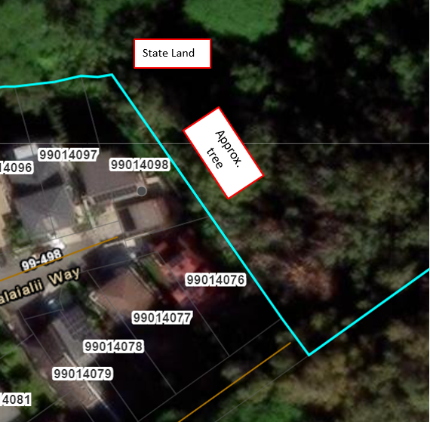

TAX MAP KEY: (1) 9-9-008:001
C2
